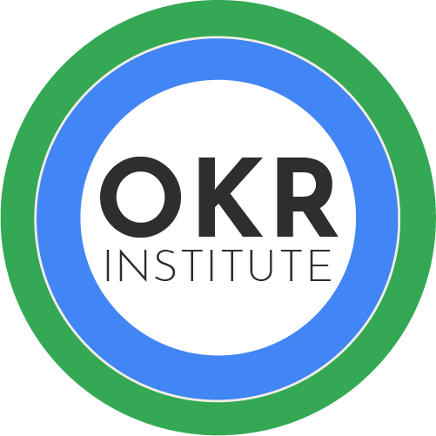

OKR

Cheat Sheet

The OKR Formula
I will (Objective) as measured by (set of Key Results)

Objectives
- Aspirational – Motivate and challenge the team.
- Memorable – Simpler, shorter and easy to memorize.
- Qualitative – No numbers.
- Fit your Culture – allows to connect with it

Key Results
- Quantitative – Every Key Result should have a number.
- Value based – Measure results instead of holding a list of tasks/deliverables/projects.
- Deliver results during the OKR Cycle – Doing a 3 months project to deliver results in the next quarter is not enough. Try breaking down your project in smaller pieces to deliver value sooner.

If you are stuck with a task, convert it in Key Results using this model:
If we are successful with , we will have more and/or less

Example:
If we are successful with the Software implementation, we will have more speed in generating reports and/or less manual work

Alignment
- Check if your OKRs are aligned with the organization's OKRs and with the other teams (use the 360° Alignment Template).
- You may have a “local” OKR, but most of your OKRs should contribute to the company's OKRs, Strategies, Vision and Mission.
- Check if you don’t have to create shared OKRs with other teams.

Focus
- Set few OKRs, less is more here. If you start implementing OKRs, start with 1 OKR in a pilot group.
- An OKR should have between 2 and 5 Key Results. If your Objective has only one Key Result, try merging it with another OKR or check if you don't have to balance it.

